Lab 1: Write a program using components to add two number and use text fields for inputs and output. Your program should display result when user press a button.
Source Code:
import javax.swing.*;
import java.awt.*;
import java.awt.event.*;
public class AddNumbers extends JFrame implements ActionListener {
JLabel l1, l2, l3;
JTextField t1, t2, t3;
JButton btn;
AddNumbers() {
setTitle("Addition Program");
setSize(300,200);
setLayout(new GridLayout(4,2));
setDefaultCloseOperation(JFrame.EXIT_ON_CLOSE);
l1 = new JLabel("Enter First Number:");
t1 = new JTextField();
l2 = new JLabel("Enter Second Number:");
t2 = new JTextField();
l3 = new JLabel("Result:");
t3 = new JTextField();
| t3.setEditable(false);
btn = new JButton("Add");
btn.addActionListener(this);
add(l1); add(t1);
add(l2); add(t2);
add(l3); add(t3);
add(btn);
setVisible(true);
}
public void actionPerformed(ActionEvent e) {
double num1 = Double.parseDouble(t1.getText());
double num2 = Double.parseDouble(t2.getText());
double result = num1 + num2;
t3.setText(String.valueOf(result));
}
public static void main(String[] args) {
new AddNumbers();
}
}
OUTPUT
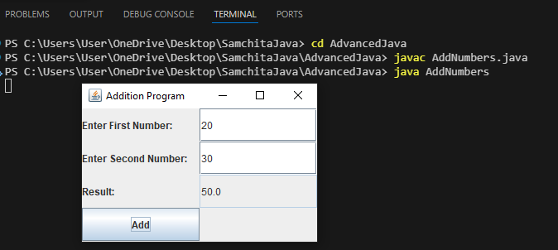

Lab2: Write a program using swing components to multiply two numbers. Use text fields for inputs and output. Your program should display the result when the user presses a button.
SOURCE CODE
import javax.swing.*;
import java.awt.*;
import java.awt.event.*;
public class MultiplyNumbers extends JFrame implements ActionListener {
JLabel l1, l2, l3;
JTextField t1, t2, t3;
JButton btn;
MultiplyNumbers() {
setTitle("Multiplication Program");
setSize(300,200);
setLayout(new GridLayout(4,2));
setDefaultCloseOperation(JFrame.EXIT_ON_CLOSE);
l1 = new JLabel("Enter First Number:");”
t1 = new JTextField();
l2 = new JLabel("Enter Second Number:");
t2 = new JTextField();
l3 = new JLabel("Result:");
t3 = new JTextField();
t3.setEditable(false);
btn = new JButton("Multiply");
btn.addActionListener(this);
add(l1); add(t1);
add(l2); add(t2);
add(l3); add(t3);
add(btn);
setVisible(true);
}
public void actionPerformed(ActionEvent e) {
double num1 = Double.parseDouble(t1.getText());
double num2 = Double.parseDouble(t2.getText());
double result = num1 * num2;
t3.setText(String.valueOf(result));
}
public static void main(String[] args) {
new MultiplyNumbers();
}
}
OUTPUT
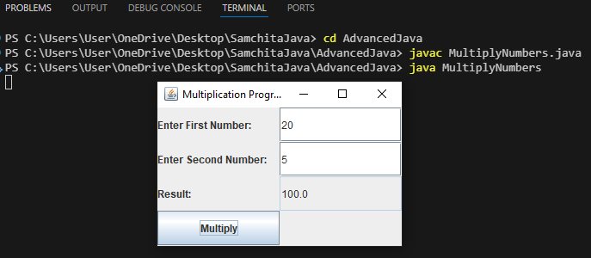

Lab 3: Write a program to illustrate the use of BorderLayout.
SOURCE CODE:
import javax.swing.*;
import java.awt.*;
public class BorderLayoutDemo extends JFrame {
BorderLayoutDemo() {
setTitle("BorderLayout Example");
setSize(400,300);
setLayout(new BorderLayout());
setDefaultCloseOperation(JFrame.EXIT_ON_CLOSE);
add(new JButton("North"), BorderLayout.NORTH);
add(new JButton("South"), BorderLayout.SOUTH);
add(new JButton("East"), BorderLayout.EAST);
add(new JButton("West"), BorderLayout.WEST);
add(new JButton("Center"), BorderLayout.CENTER);
setVisible(true);
}
public static void main(String[] args) {
new BorderLayoutDemo();
}
}
OUTPUT:
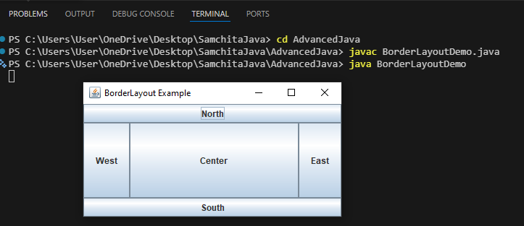
Lab 5: Create a login form with username and password fields. Print “access granted” if the username and password both are “admin”, when user clicks on Login button. If authentication fails, print “access denied”.
Source Code:
import javax.swing.*;
import java.awt.*;
import java.awt.event.ActionEvent;
import java.awt.event.ActionListener;
public class LoginForm {
public static void main(String[] args) {
// Create the frame (window)
JFrame frame = new JFrame("Login Form");
frame.setSize(300, 150);
frame.setDefaultCloseOperation(JFrame.EXIT_ON_CLOSE);
frame.setLayout(new GridLayout(3, 2));
// Create components
JLabel userLabel = new JLabel(" Username:");
JTextField userField = new JTextField();
JLabel passLabel = new JLabel(" Password:");
JPasswordField passField = new JPasswordField();
JButton loginButton = new JButton("Login");
// Add components to frame
frame.add(userLabel);
frame.add(userField);
frame.add(passLabel);
frame.add(passField);
frame.add(new JLabel("")); // Empty space for layout
frame.add(loginButton);
// Add action listener to button
loginButton.addActionListener(new ActionListener() {
@Override
public void actionPerformed(ActionEvent e) {
String username = userField.getText();
String password = new String(passField.getPassword());
// Authentication logic
if (username.equals("admin") && password.equals("admin")) {
System.out.println("access granted");
} else {
System.out.println("access denied");
}
}
});
// Display the window
frame.setVisible(true);
}
}
OUTPUT
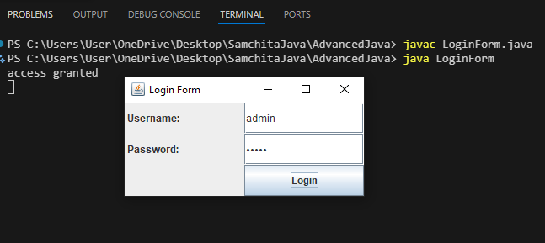

5. Create a basic notepad app with the following features:
a) New
b) Open
c) Save
d) Exit;
Use JButton components to implement these features.
SOURCE CODE:
import javax.swing.*;
import java.awt.*;
import java.awt.event.ActionEvent;
import java.awt.event.ActionListener;
import java.io.*;
public class SimpleNotepad extends JFrame implements ActionListener {
JTextArea textArea;
JButton newButton, openButton, saveButton, exitButton;
JFileChooser fileChooser;
public SimpleNotepad() {
// Frame setup
setTitle("Simple Notepad");
setSize(600, 500);
setDefaultCloseOperation(EXIT_ON_CLOSE);
setLayout(new BorderLayout());
// Text Area
textArea = new JTextArea();
add(new JScrollPane(textArea), BorderLayout.CENTER);
// Buttons Panel
JPanel buttonPanel = new JPanel();
newButton = new JButton("New");
openButton = new JButton("Open");
saveButton = new JButton("Save");
exitButton = new JButton("Exit");
// Add action listeners
newButton.addActionListener(this);
openButton.addActionListener(this);
saveButton.addActionListener(this);
exitButton.addActionListener(this);
buttonPanel.add(newButton);
buttonPanel.add(openButton);
buttonPanel.add(saveButton);
buttonPanel.add(exitButton);
add(buttonPanel, BorderLayout.SOUTH);
fileChooser = new JFileChooser();
}
@Override
public void actionPerformed(ActionEvent e) {
if (e.getSource() == newButton) {
textArea.setText("");
} else if (e.getSource() == openButton) {
int returnValue = fileChooser.showOpenDialog(null);
if (returnValue == JFileChooser.APPROVE_OPTION) {
File selectedFile = fileChooser.getSelectedFile();
try (BufferedReader br = new BufferedReader(new FileReader(selectedFile))) {
textArea.read(br, null);
} catch (IOException ex) {
ex.printStackTrace();
}
}
} else if (e.getSource() == saveButton) {
int returnValue = fileChooser.showSaveDialog(null);
if (returnValue == JFileChooser.APPROVE_OPTION) {
File fileToSave = fileChooser.getSelectedFile();
try (BufferedWriter bw = new BufferedWriter(new FileWriter(fileToSave))) {
textArea.write(bw);
} catch (IOException ex) {
ex.printStackTrace();
}
}
} else if (e.getSource() == exitButton) {
System.exit(0);
}
}
public static void main(String[] args) {
SwingUtilities.invokeLater(() -> {
new SimpleNotepad().setVisible(true);|
});
}
}
OUTPUT
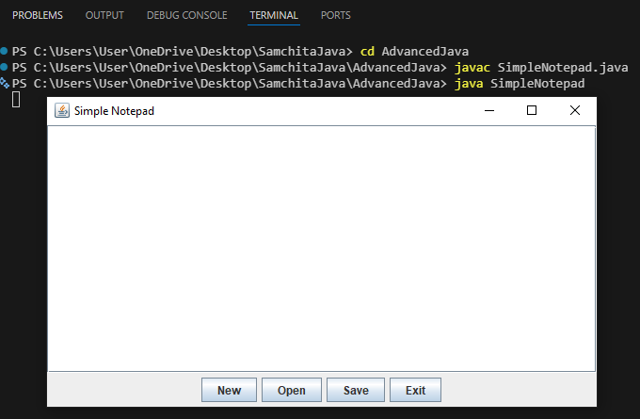

6. Create a form using JFrame to collect the records of students in Asian College. Each record should contain the following information:
a) First Name (JTextField)
b) Last Name (JTextField)
c) Age (JTextField)
d) Gender (JRadioButton)
e) Faculty (JComboBox/JList)
f) Semester (JComboBox/IList)
g) Remarks (JTextArea)
SOURCE CODE:
import javax.swing.*;
import java.awt.*;
public class StudentForm extends JFrame {
private JTextField firstNameField, lastNameField, ageField;
private JRadioButton maleRadio, femaleRadio;
private JComboBox<String> facultyCombo, semesterCombo;
private JTextArea remarksArea;
private JButton submitButton;
public StudentForm() {
// Frame Setup
setTitle("Amrit Science Campus - Student Registration");
setSize(400, 500);
setDefaultCloseOperation(EXIT_ON_CLOSE);
setLocationRelativeTo(null); // Center on screen
// Use GridBagLayout for a structured form
setLayout(new GridBagLayout());
GridBagConstraints gbc = new GridBagConstraints();
gbc.insets = new Insets(5, 5, 5, 5); // Spacing
gbc.fill = GridBagConstraints.HORIZONTAL;
// --- Form Components ---
// a) First Name
addComponent(new JLabel("First Name:"), 0, 0, gbc);
firstNameField = new JTextField(15);
addComponent(firstNameField, 0, 1, gbc);
// b) Last Name
addComponent(new JLabel("Last Name:"), 1, 0, gbc);
lastNameField = new JTextField(15);
addComponent(lastNameField, 1, 1, gbc);
// c) Age
addComponent(new JLabel("Age:"), 2, 0, gbc);
ageField = new JTextField(15);
addComponent(ageField, 2, 1, gbc);
// d) Gender (Radio Buttons)
addComponent(new JLabel("Gender:"), 3, 0, gbc);
JPanel genderPanel = new JPanel(new FlowLayout(FlowLayout.LEFT));
maleRadio = new JRadioButton("Male");
femaleRadio = new JRadioButton("Female");
ButtonGroup genderGroup = new ButtonGroup();
genderGroup.add(maleRadio);
genderGroup.add(femaleRadio);
genderPanel.add(maleRadio);
genderPanel.add(femaleRadio);
addComponent(genderPanel, 3, 1, gbc);
// e) Faculty
addComponent(new JLabel("Faculty:"), 4, 0, gbc);
String[] faculties = {"Computer Science and Information Technology", "B.Sc", "BIT"};
facultyCombo = new JComboBox<>(faculties);
addComponent(facultyCombo, 4, 1, gbc);
// f) Semester
addComponent(new JLabel("Semester:"), 8, 0, gbc);
String[] semesters = {"Semester 1", "Semester 2", "Semester 3", "Semester 4", "Semester 5", "Semester 6", "Semester 7", "Semester 8"};
semesterCombo = new JComboBox<>(semesters);
addComponent(semesterCombo, 5, 1, gbc);
// g) Remarks
addComponent(new JLabel("Remarks:"), 6, 0, gbc);
remarksArea = new JTextArea(4, 15);
remarksArea.setBorder(BorderFactory.createLineBorder(Color.LIGHT_GRAY));
JScrollPane scrollPane = new JScrollPane(remarksArea);
addComponent(scrollPane, 6, 1, gbc);
// Submit Button
submitButton = new JButton("Submit");
gbc.gridx = 0;
gbc.gridy = 7;
gbc.gridwidth = 2; // Span across two columns
add(submitButton, gbc);|
// Basic Action Listener
submitButton.addActionListener(e -> {
JOptionPane.showMessageDialog(this, "Record Submitted Successfully!");
});
}
// Helper method to add components to GridBagLayout
private void addComponent(Component component, int row, int col, GridBagConstraints gbc)
{
gbc.gridx = col;
gbc.gridy = row;
add(component, gbc);
}
public static void main(String[] args) {
SwingUtilities.invokeLater(() -> {
new StudentForm().setVisible(true);
});
}
}
OUTPUT:
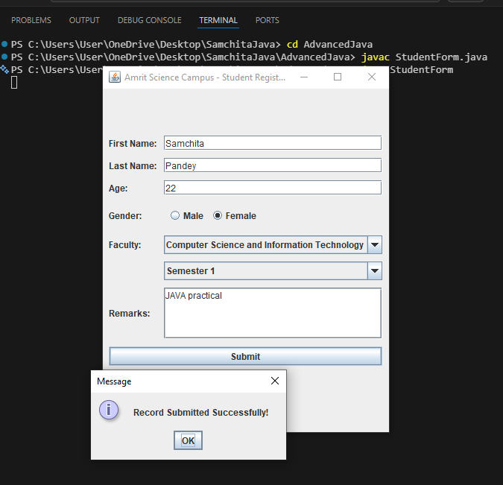

Lab 7: Write a java code to connect database and perform insert, select, delete and update operations (CRUD) in database table.
Source Code:
import java.sql.*;
public class CRUDExample {
public static void main(String[] args) {
try {
// 1. Load Driver
Class.forName("com.mysql.cj.jdbc.Driver");
// 2. Establish Connection
Connection con = DriverManager.getConnection(
"jdbc:mysql://localhost:3306/college", "root", "MERO@ms321");
System.out.println("Connected to database!");
// 3. INSERT
String insertQuery = "INSERT INTO student VALUES (1, 'Ram')";
Statement stmt = con.createStatement();
stmt.executeUpdate(insertQuery);
System.out.println("Record Inserted!");
// 4. SELECT
String selectQuery = "SELECT * FROM student";
ResultSet rs = stmt.executeQuery(selectQuery);
System.out.println("Records:");
while(rs.next()) {
System.out.println(rs.getInt("id") + " " + rs.getString("name"));
}
// 5. UPDATE
String updateQuery = "UPDATE student SET name='Shyam' WHERE id=1";
stmt.executeUpdate(updateQuery);
System.out.println("Record Updated!");
// 6. DELETE
String deleteQuery = "DELETE FROM student WHERE id=1";
stmt.executeUpdate(deleteQuery);
System.out.println("Record Deleted!");
// Close connection
con.close();
} catch(Exception e) {
System.out.println(e);
}
}
}
SQL QUERY
CREATE DATABASE college;
USE college;
CREATE TABLE student(
id INT,
name VARCHAR(50)
);
SHOW DATABASES;
SHOW TABLES;

OUTPUT
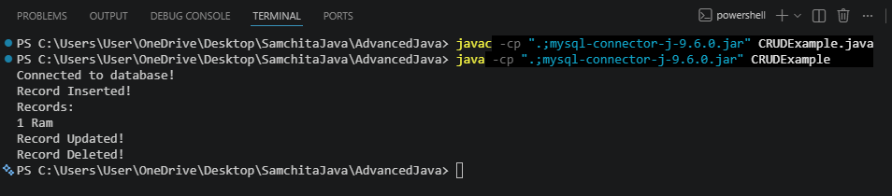

Lab 8: Write a program using Connection oriented Socket Programming that can read write on both side.
SOURCE CODE:
- ChatServer.java
package SocketChatApp;
import java.io.*;
import java.net.*;
public class ChatServer {
public static void main(String[] args) {
ServerSocket serverSocket = null;
Socket socket = null;
try {
serverSocket = new ServerSocket(5000);
System.out.println("Server started. Waiting for client...");
socket = serverSocket.accept();
System.out.println("Client connected!");
BufferedReader input = new BufferedReader(|
new InputStreamReader(socket.getInputStream()));
PrintWriter output = new PrintWriter(socket.getOutputStream(), true);
BufferedReader keyboard = new BufferedReader(
new InputStreamReader(System.in));
String clientMsg, serverMsg;
while (true) {
clientMsg = input.readLine();
if (clientMsg == null || clientMsg.equalsIgnoreCase("bye")) {
System.out.println("Connection closed.");
break;
}
System.out.println("Client: " + clientMsg);
System.out.print("You: ");
serverMsg = keyboard.readLine();
output.println(serverMsg);
if (serverMsg.equalsIgnoreCase("bye")) {
System.out.println("Connection closed.");
break;
}
}
} catch (Exception e) {
System.out.println(e);
} finally {
try {
if (socket != null) socket.close();
if (serverSocket != null) serverSocket.close();
} catch (IOException e) {
System.out.println(e);
}
}
}
}
- ChatClient.java
package SocketChatApp;
import java.io.*;
import java.net.*;
public class ChatClient {|
public static void main(String[] args) {
Socket socket = null;
BufferedReader input = null;
PrintWriter output = null;
BufferedReader keyboard = null;
try {
socket = new Socket("localhost", 5000);
input = new BufferedReader(
new InputStreamReader(socket.getInputStream()));
output = new PrintWriter(socket.getOutputStream(), true);
keyboard = new BufferedReader(
new InputStreamReader(System.in));
String serverMsg, clientMsg;
System.out.println("Connected to server!");
while (true) {
System.out.print("You: ");
clientMsg = keyboard.readLine();
output.println(clientMsg);
if (clientMsg.equalsIgnoreCase("bye")) {
System.out.println("Connection closed.");
break;
}
serverMsg = input.readLine();
if (serverMsg == null || serverMsg.equalsIgnoreCase("bye")) {
System.out.println("Server closed connection.");
break;
}
System.out.println("Server: " + serverMsg);
}
} catch (Exception e) {
System.out.println(e);
} finally {
try {
if (keyboard != null) keyboard.close();
if (input != null) input.close();
if (output != null) output.close();
if (socket != null) socket.close();
} catch (IOException e) {
System.out.println(e);
}
}
}
}
OUTPUT
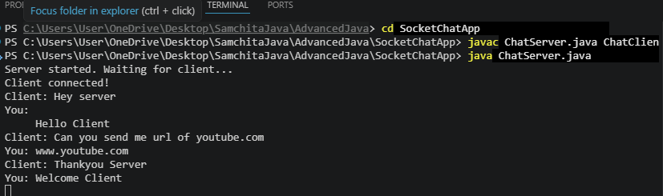
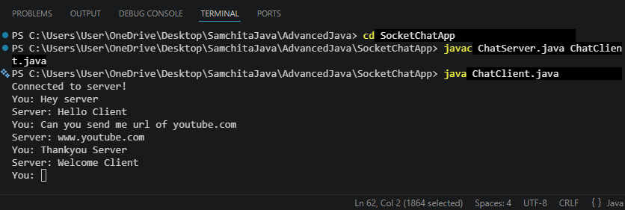

Lab 9: Write client and server programs in which a server program accepts a radius of a circle from the client program computes area, sends the computed area to the client program, and displays it by client program.
SOURCE CODE:
i) AreaServer.java
package CircleArea;
import java.io.*;
import java.net.*;
public class AreaServer {|
public static void main(String[] args) {
try {
ServerSocket serverSocket = new ServerSocket(5000);
System.out.println("Server started. Waiting for client...");
Socket socket = serverSocket.accept();
System.out.println("Client connected!");
BufferedReader input = new BufferedReader(
new InputStreamReader(socket.getInputStream()));
PrintWriter output = new PrintWriter(socket.getOutputStream(), true);
String radiusStr = input.readLine();
double radius = Double.parseDouble(radiusStr);
double area = 3.1416 * radius * radius;
output.println(area);
System.out.println("Area calculated and sent to client: " + area);
socket.close();
serverSocket.close();
} catch (Exception e) {
System.out.println(e);
}
}
}
ii) AreaClient.java
package CircleArea;
import java.io.*;
import java.net.*;
public class AreaClient {
public static void main(String[] args) {
try {
Socket socket = new Socket("localhost", 5000);
BufferedReader input = new BufferedReader(
new InputStreamReader(socket.getInputStream()));
PrintWriter output = new PrintWriter(socket.getOutputStream(), true);
BufferedReader keyboard = new BufferedReader(
new InputStreamReader(System.in));
// Step 1: Take radius from user
System.out.print("Enter radius: ");
String radius = keyboard.readLine();
// Step 2: Send radius to server
output.println(radius);
// Step 3: Receive area from server
String area = input.readLine();
System.out.println("Area of circle is: " + area);
// Close connections
socket.close();
} catch (Exception e) {
System.out.println(e);
}
}
}
OUTPUT
AreaServer.java
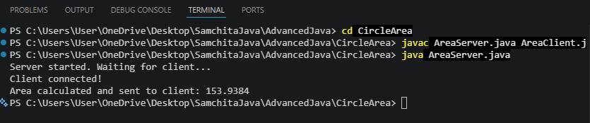
AreaClient.java
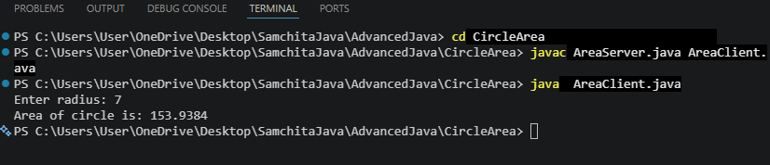
10. Write program for client server application using TCP and UDP.
SOURCE CODE:
- TCPServer.java
import java.io.*;
import java.net.*;
public class TCPServer {
public static void main(String[] args) {
try {
ServerSocket serverSocket = new ServerSocket(5000);
System.out.println("TCP Server started... Waiting for client");
Socket socket = serverSocket.accept();
System.out.println("Client connected!");
BufferedReader input = new BufferedReader(
new InputStreamReader(socket.getInputStream()));
PrintWriter output = new PrintWriter(socket.getOutputStream(), true);
String message = input.readLine();
System.out.println("Client: " + message);
output.println("Message received by server");
socket.close();
serverSocket.close();
} catch (Exception e) {
System.out.println(e);
}
}
}
- TCPClient.java
import java.io.*;
import java.net.*;
public class TCPClient {
public static void main(String[] args) {
try {
Socket socket = new Socket("localhost", 5000);
BufferedReader input = new BufferedReader(
new InputStreamReader(socket.getInputStream()));
PrintWriter output = new PrintWriter(socket.getOutputStream(), true);
BufferedReader keyboard = new BufferedReader(
new InputStreamReader(System.in));
System.out.print("Enter message: ");
String msg = keyboard.readLine();
output.println(msg);
String response = input.readLine();
System.out.println("Server: " + response);
socket.close();
} catch (Exception e) {
System.out.println(e);
}
}
}
c) UDP Server
import java.net.*;
public class UDPServer {
public static void main(String[] args) {
try {
DatagramSocket socket = new DatagramSocket(5000);
byte[] receiveData = new byte[1024];
DatagramPacket receivePacket =
new DatagramPacket(receiveData, receiveData.length);
socket.receive(receivePacket);
String message = new String(receivePacket.getData(), 0, receivePacket.getLength());
System.out.println("Client: " + message);
String response = "Message received (UDP Server)";
byte[] sendData = response.getBytes();
InetAddress ip = receivePacket.getAddress();|
int port = receivePacket.getPort();
DatagramPacket sendPacket =
new DatagramPacket(sendData, sendData.length, ip, port);
socket.send(sendPacket);
socket.close();
} catch (Exception e) {
System.out.println(e);
}
}
}
- UDP Client
import java.net.*;
import java.util.Scanner;
public class UDPClient {
public static void main(String[] args) {
try {
DatagramSocket socket = new DatagramSocket();
Scanner sc = new Scanner(System.in);
System.out.print("Enter message: ");
String msg = sc.nextLine();
byte[] sendData = msg.getBytes();
InetAddress ip = InetAddress.getByName("localhost");
DatagramPacket sendPacket =
new DatagramPacket(sendData, sendData.length, ip, 5000);
socket.send(sendPacket);
byte[] receiveData = new byte[1024];
DatagramPacket receivePacket =
new DatagramPacket(receiveData, receiveData.length);
socket.receive(receivePacket);
String response = new String(receivePacket.getData(), 0, receivePacket.getLength());
System.out.println("Server: " + response);
socket.close();
} catch (Exception e) {
System.out.println(e);
}
}
}

OUTPUT
TCPServer
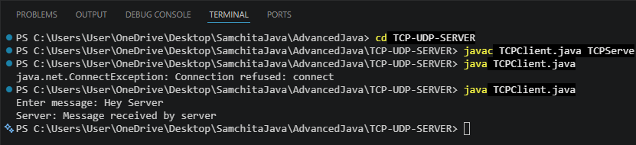
TCPClient
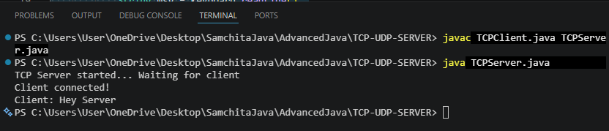
UDPServer
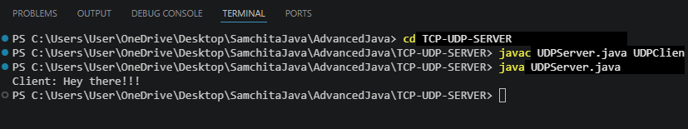
UDPClient
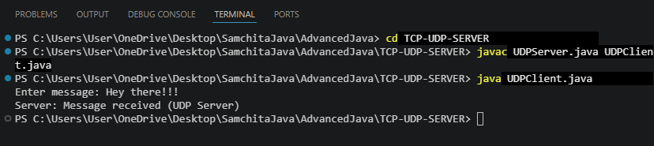
Lab 11: Write a program that illustrate Handling HTTP Request and Response using servlets.
SOURCE CODE:
1) Servlet.java:
import java.io.IOException;
import java.io.PrintWriter;
import jakarta.servlet.ServletException;
import jakarta.servlet.http.HttpServlet;
import jakarta.servlet.http.HttpServletRequest;
import jakarta.servlet.http.HttpServletResponse;
public class MyServlet extends HttpServlet {
protected void doGet(HttpServletRequest request, HttpServletResponse response)
throws ServletException, IOException {
// Set response type
response.setContentType("text/html");
// Get PrintWriter object to send response
PrintWriter out = response.getWriter();
// Read data from request (URL parameter)
String name = request.getParameter("name");
// Default value if no input is given
if (name == null || name.equals("")) {
name = "Guest";
}
// Write response to browser
out.println("<html><body>");
out.println("<h2>HTTP Request and Response Example</h2>");
out.println("<p>Hello, " + name + "</p>");
out.println("</body></html>");
}
}
2) web.xml
<web-app>
<servlet>
<servlet-name>MyServlet</servlet-name>
<servlet-class>MyServlet</servlet-class>
</servlet>
<servlet-mapping>
<servlet-name>MyServlet</servlet-name>
<url-pattern>/hello</url-pattern>
</servlet-mapping>
</web-app>
OUTPUT
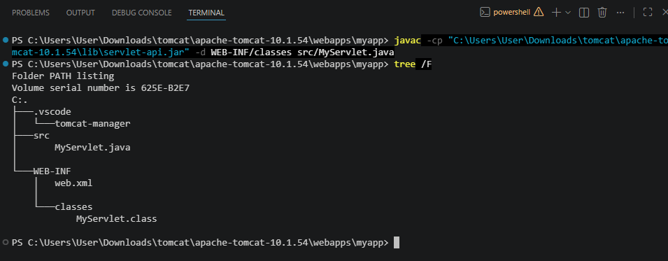
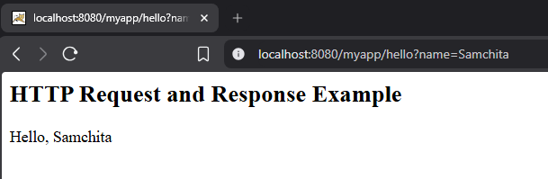

Lab 12: Write a simple JSP program to display “Tribhuvan University” 10 times.
SOURCE CODE:
index.jsp
<%
out.println("By SamchitaPandey <br> <br>");
for(int i=1; i<=10; i++)
{
%>
Tribhuvan University <br>
<%
}
%>

OUTPUT
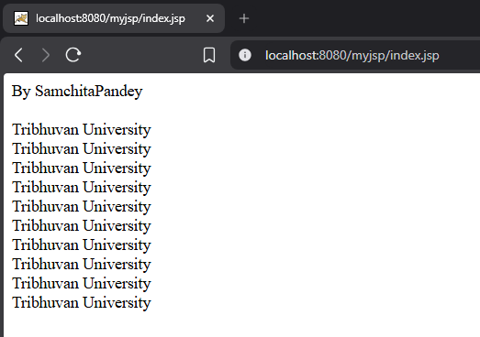

13. Write a program to create a JSP web form to take input of a student and submit it to second JSP file which may simply print the values of form submission.
SOURCE CODE
1) studentForm.jsp
<html>
<body>
<h2>Student Registration Form</h2>
<form action="showStudent.jsp" method="post">
Name: <input type="text" name="name"><br><br>
Roll No: <input type="text" name="roll"><br><br>
Faculty: <input type="text" name="faculty"><br><br>
<input type="submit" value="Submit">
</form>
</body>
</html>

2) showStudent.jsp
<%
String name = request.getParameter("name");
String roll = request.getParameter("roll");
String faculty = request.getParameter("faculty");
%>
<html>
<body>
<h2>Student Details</h2>
Name: <%= name %> <br><br>
Roll No: <%= roll %> <br><br>
Faculty: <%= faculty %> <br><br>
</body>
</html>
OUTPUT
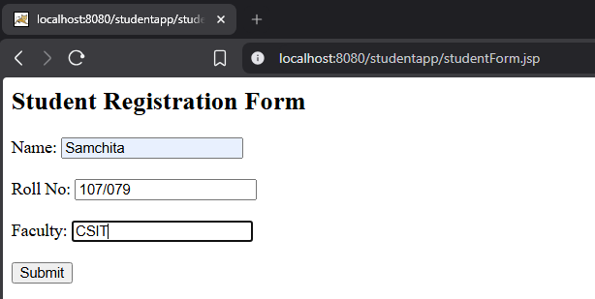
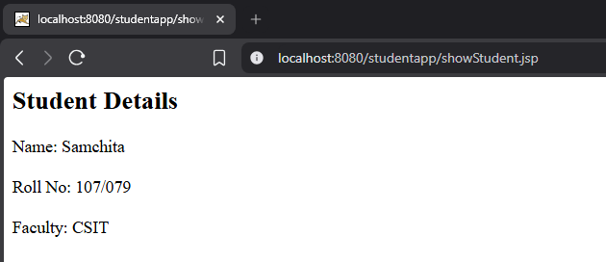

Lab 14: Write a program using RMI to find sum and difference of two numbers. Methods sum and difference should be invoked from some remote machine.
SOURCE CODE:
1) Calculator.java
import java.rmi.Remote;
import java.rmi.RemoteException;
public interface Calculator extends Remote {
public int sum(int a, int b) throws RemoteException;
public int difference(int a, int b) throws RemoteException;
}
2) CalculatorImp1.java
import java.rmi.Remote;
import java.rmi.server.UnicastRemoteObject;
import java.rmi.RemoteException;
public class CalculatorImpl extends UnicastRemoteObject implements Calculator {
public CalculatorImpl() throws RemoteException {
super();
}
public int sum(int a, int b) throws RemoteException {
return a + b;
}
public int difference(int a, int b) throws RemoteException {
return a - b;
}
}
3) Client.java
import java.rmi.Remote;
import java.rmi.RemoteException;
import java.rmi.Naming;
public class Client {
public static void main(String[] args) {
try {
Calculator obj = (Calculator) Naming.lookup("rmi://localhost/CalculatorService");
int a = 10;
int b = 5;
System.out.println("Sum: " + obj.sum(a, b));
System.out.println("Difference: " + obj.difference(a, b));
} catch (Exception e) {
System.out.println(e);
}
}
}
4) Server.java
public class Server {
public static void main(String[] args) {
try {
Naming.rebind("rmi://localhost/CalculatorService", new CalculatorImpl());
System.out.println("Server is ready...");
CalculatorImpl obj = new CalculatorImpl();
Naming.rebind("rmi://localhost/CalculatorService", obj);
System.out.println("Server is ready...");
} catch (Exception e) {
System.out.println(e);
}
}
}

OUTPUT
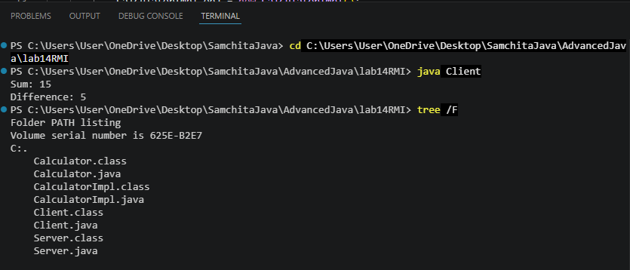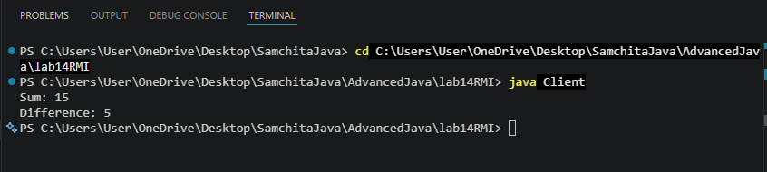
Lab 15: Program that illustrate the example of servlet and database.
SOURCE CODE
- UserServlet.java
import java.io.*;
import jakarta.servlet.*;
import jakarta.servlet.http.*;
import java.sql.*;
public class UserServlet extends HttpServlet {
public void doPost(HttpServletRequest request, HttpServletResponse response)
throws ServletException, IOException {
response.setContentType("text/html");
PrintWriter out = response.getWriter();
// Get form data
String name = request.getParameter("name");
String email = request.getParameter("email");
try {
// Load MySQL driver
Class.forName("com.mysql.cj.jdbc.Driver");
// Database connection
Connection con = DriverManager.getConnection(
"jdbc:mysql://localhost:3306/testdb",
"root",
"MERO@ms321"
);
// Insert query
PreparedStatement ps = con.prepareStatement(
"INSERT INTO users(name, email) VALUES(?, ?)"
);
ps.setString(1, name);
ps.setString(2, email);
int i = ps.executeUpdate();
if(i > 0) {
out.println("Data inserted successfully!");
}
con.close();
} catch(Exception e) {
out.println(e);
}
}
}

- Web.xml

<web-app>

<servlet>
<servlet-name>UserServlet</servlet-name>
<servlet-class>UserServlet</servlet-class>
</servlet>

<servlet-mapping>
<servlet-name>UserServlet</servlet-name>
<url-pattern>/UserServlet</url-pattern>
</servlet-mapping>

</web-app>

3) index.html
<!DOCTYPE html>
<html>
<body>

<h2>User Form</h2>

<form action="UserServlet" method="post">
Name: <input type="text" name="name"><br><br>
Email: <input type="text" name="email"><br><br>
<input type="submit" value="Submit">
</form>

</body>
</html>

- SQL QUERY
CREATE DATABASE testdb;
USE testdb;
CREATE TABLE users (
id INT AUTO_INCREMENT PRIMARY KEY,
name VARCHAR(100),
email VARCHAR(100)
);
USE testdb;
SELECT * FROM users;
OUTPUT
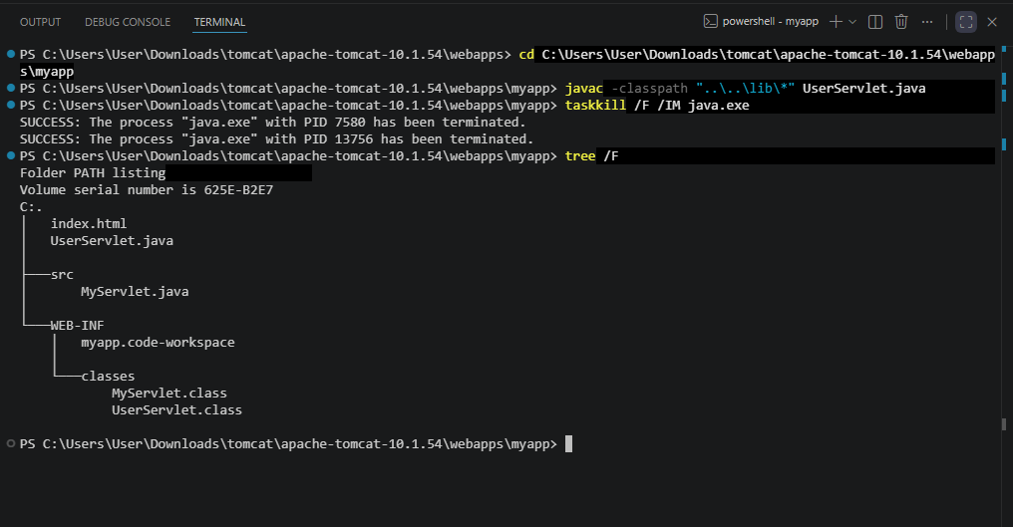
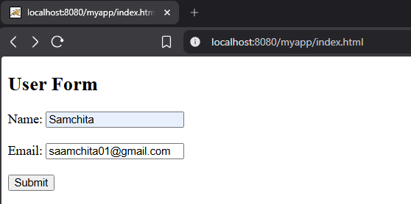
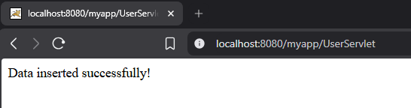
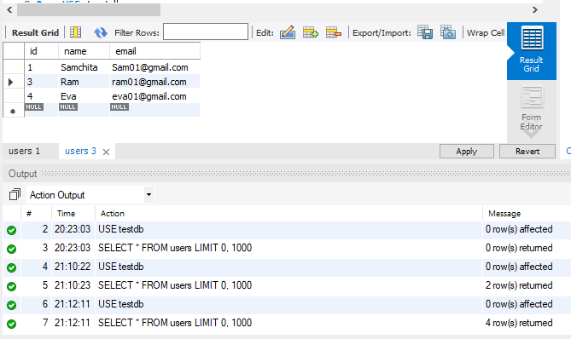
Lab 16: Program to illustrate example of criplet tag, declaration tag, and expression tag.
SOURCE CODE
1)Index.jsp
<%@ page language="java" contentType="text/html; charset=UTF-8" %>
<html>
<head>
<title>JSP Demo Home</title>
</head>
<body>
<h2>Welcome to JSP Tag Demonstration</h2>
<p>This project demonstrates:</p>
<ul>
<li>Declaration Tag (&lt;%! %&gt;)</li>
<li>Scriptlet Tag (&lt;% %&gt;)</li>
<li>Expression Tag (&lt;%= %&gt;)</li>
</ul>
<!-- Link to demo.jsp -->
<a href="demo.jsp">Click here to see JSP Tags Example</a>
</body>
</html>
OUTPUT
